[ A.A. 2024/25

CALL FOR ERASMUS+ MOBILITY FOR STUDY
Produced by the Erasmus+ Mobility Studies Unit and the International Mobility and Adm. Dep't Instruction and Higher Education

[Att. 5 –ERASMUS+ APPLICATION GUIDE Erasmus+ ]

NOTICE TO CANDIDATES

Please read the following documents carefully:

✓ Erasmus+ Study Call A.A. 2024-2025
✓ All Call attachments
✓ List of destinations and forms

IMPORTANT:

Before you begin the online application for the Erasmus Call, we suggest that you click on your online Esse3 “LIBRETTO” to check if all of the exams passed are registered correctly. Before filling out the online application, students are advised to check the data contained in the “anagrafica” and update it in the area “Recapito” with current telephone numbers, email addresses, etc.

Identification of applicants is ascertained through the use of the personal credentials used to activate the system. Declarations will be verified according to law.

To access your Reserved UNIME esse3 area go to this link: https://unime.esse3.cineca.it/Home.do
Click on LOGIN and insert: USER NAME AND PASSWORD

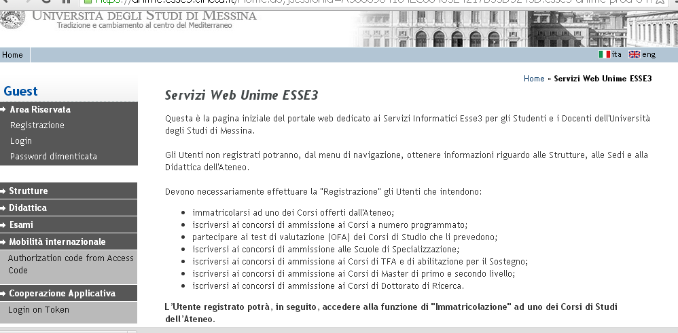

In the left column choose BANDI DI MOBILITA’ under the heading MOBILITA’ INTERNAZIONALE

The Call for your Department will appear in the table “Ambito Mobilità”.

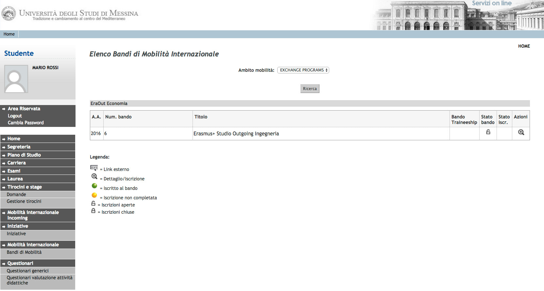

In the right column “Azioni”, click on the magnifying glass to begin filling out the online application.

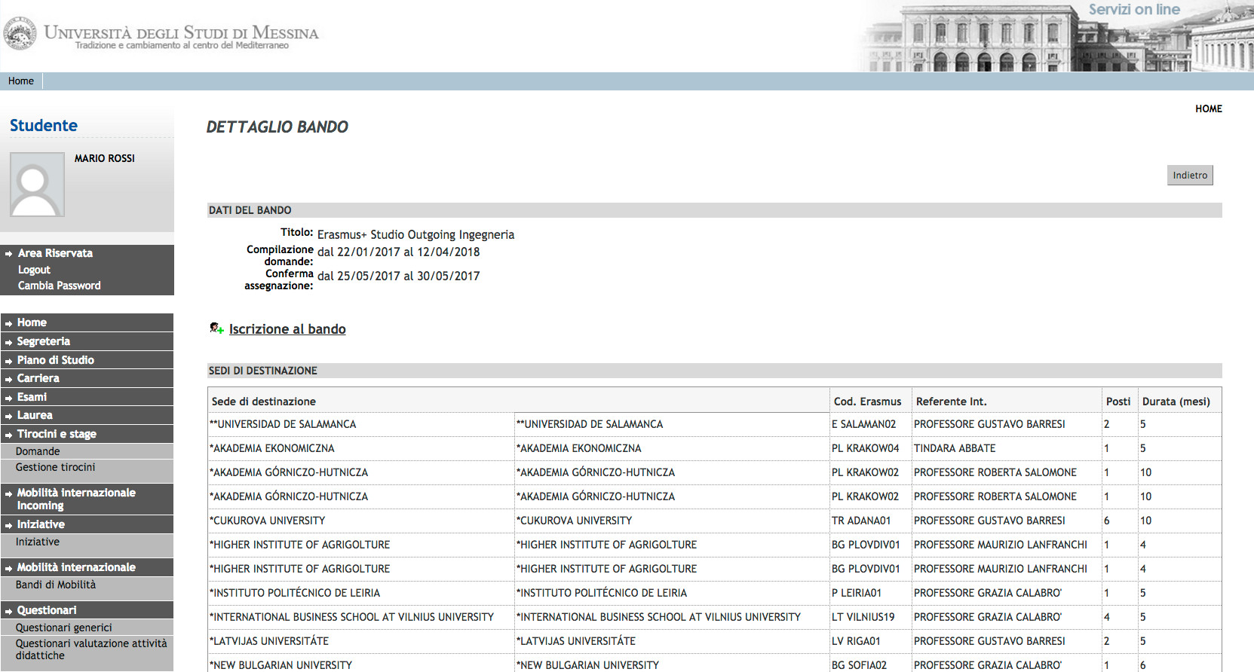

Click on “Iscrizione al Bando”

Before starting the application it is mandatory to indicate some important information in the section “REQUISITO”

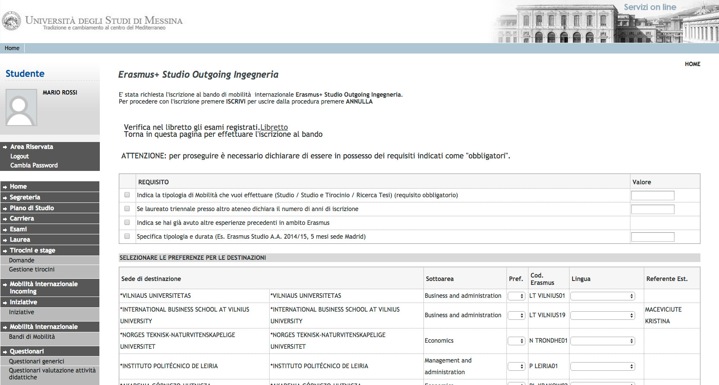

It is necessary to choose the type of mobility that you are applying for: Study (“Studio”); Study + traineeship: combined mobility (“Studio+Tirocinio: mobilità combinata); or Thesis research (“Ricerca tesi”). You must also declare any previous Erasmus+ mobility experience (esperienze precedenti in ambito mobilità Erasmus).

(Mandatory requirements)

Now, it is possible to choose destinations in order of preference, being aware that any of the chosen destinations could be assigned. It is also necessary to pay attention to the language competency level required by the host institution.

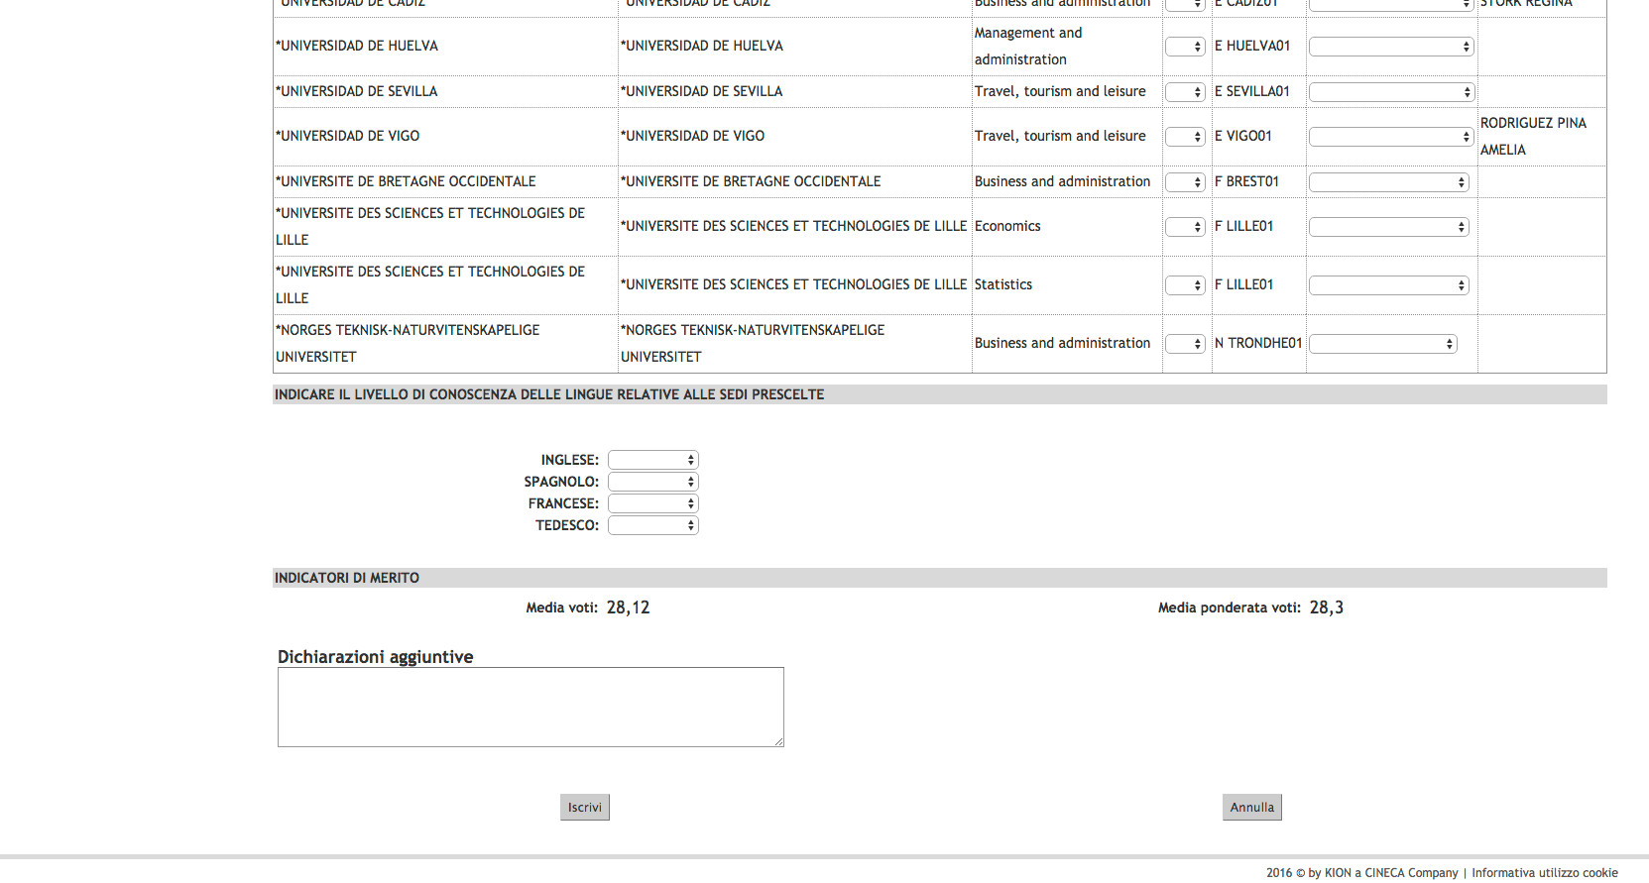

ATTENTION! If the language competence required by a chosen host institution does not coincide with the declared level, the application will be blocked and not allowed to go forward.

After selecting the destinations, choose the level of language knowledge that will be confirmed by uploading the document on the next screen. Insert any useful information in the area “dichiarazioni aggiuntive” and click on “ISCRIVI”.

ATTENTION! Only the certifications/self-certifications listed in Art. 2.3 of the call will be considered valid.

If everything has been completed correctly, the following statement will appear:
ISCRIZIONE CON SUCCESSO (successful application)

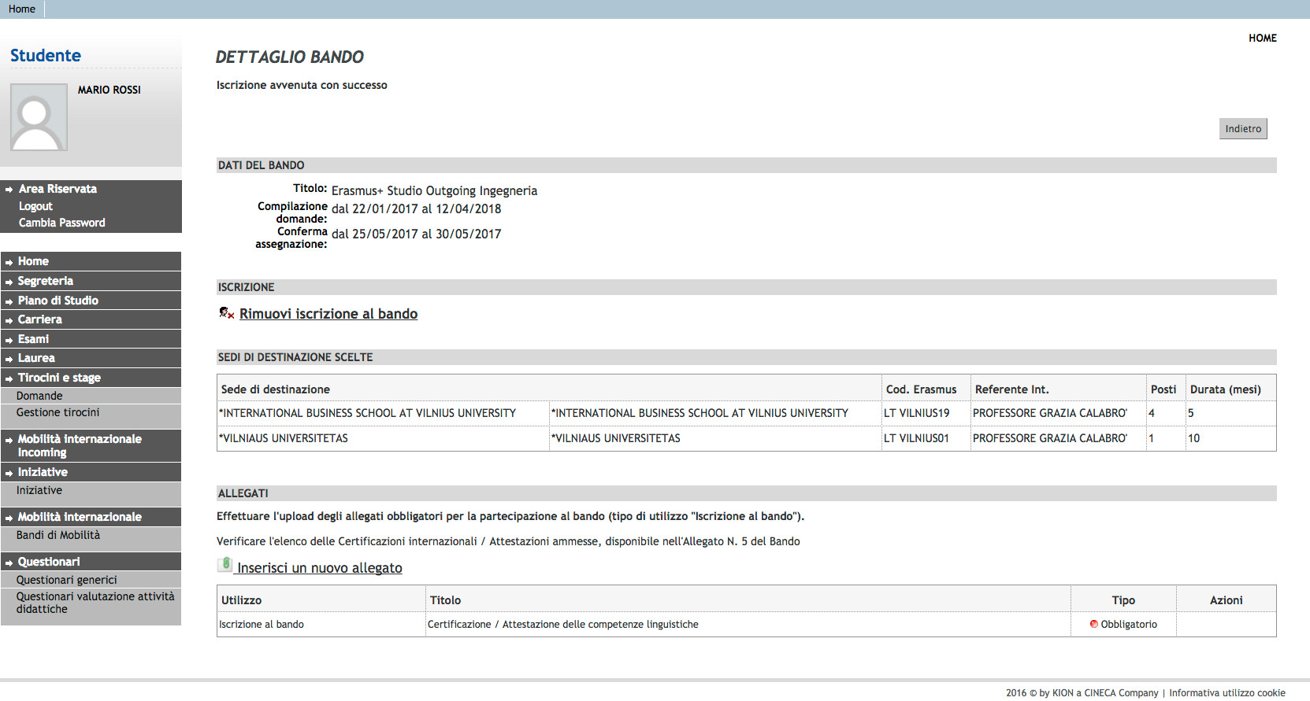

In this phase it is possible to check the accuracy of the data entered and the completion of the attached documents. In case it is necessary to cancel the application, choose “ RIMUOVI ISCRIZIONE AL BANDO”.

Before finishing the application it is necessary to upload the own language certifications/selfcertifications: select “inserire un nuovo allegato”, press “Sfoglia” to upload the file (mandatory pdf form) from your own pc and then click “Allega”.

ATTENTION! If the student has more than one language certification/selfcertification relating to different languages, these documents must be attached in a SINGLE PDF FILE.

After the upload, you can check if the application was completed correctly by verifying directly your Esse3 account under the heading “Bandi di mobilit{”. If a green ball is visible, your application to the Erasmus+Study Call A.A. 2024-25 has been correctly registered.

GOOD LUCK!
Per ulteriori info:
Unità Operativa Mobilità per Studio
Unità Organizzativa Mobilità Internazionale
Università degli Studi di Messina
Orario di apertura al pubblico: MON – THU from 9.00 to 12.30pm
Orario di ricevimento telefonico (helpdesk Bando): Wednesday from 3pm to 4pm, Friday from 10.00 to 12.00pm.
Tel: 090/676 8532-8349 E-mail: erasmus@unime.it

